Task 5 : Capture and Analyze Network Traffic Using Wireshark

#IMAGES

#Open the wireshark site

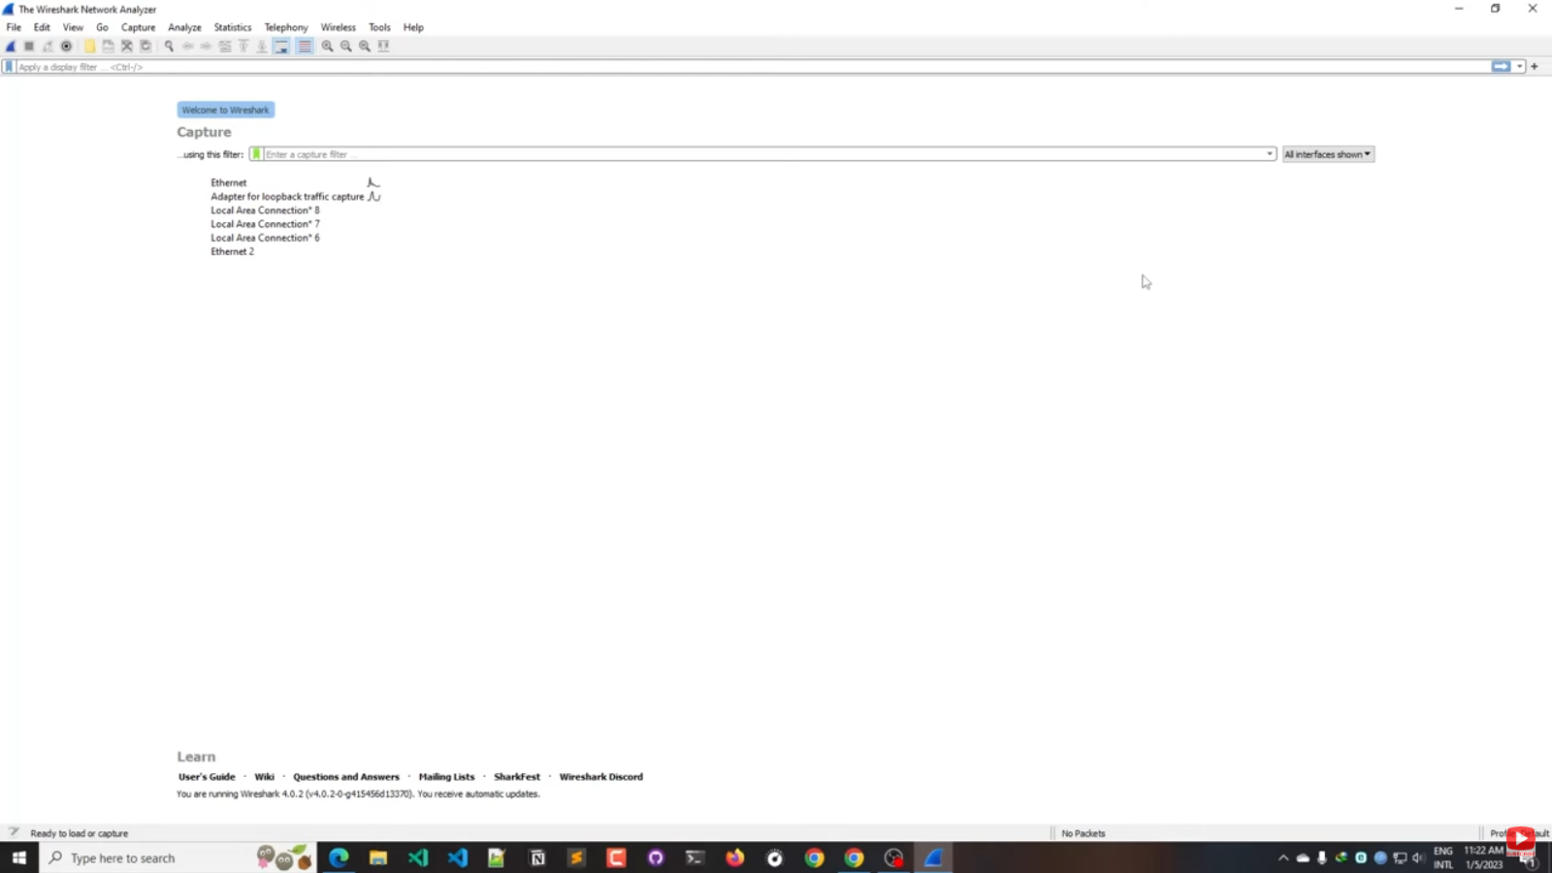

#select the network connection or adapter

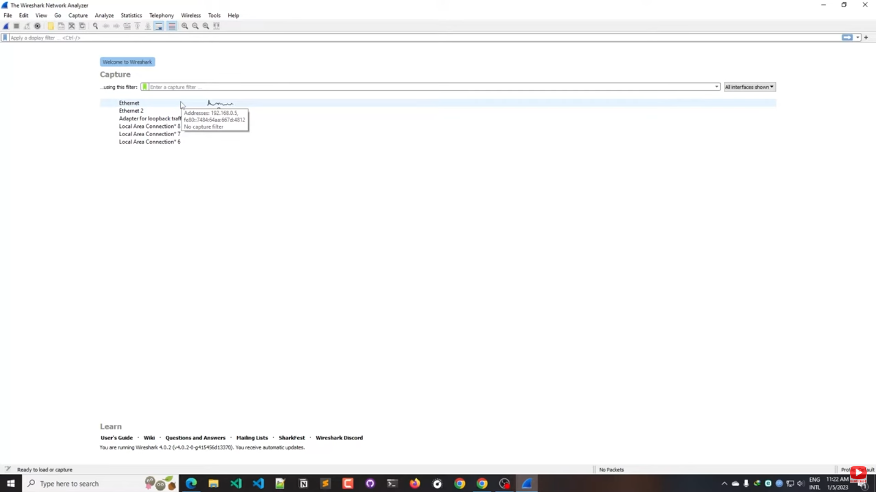

#After selecting it will start collecting all data packets

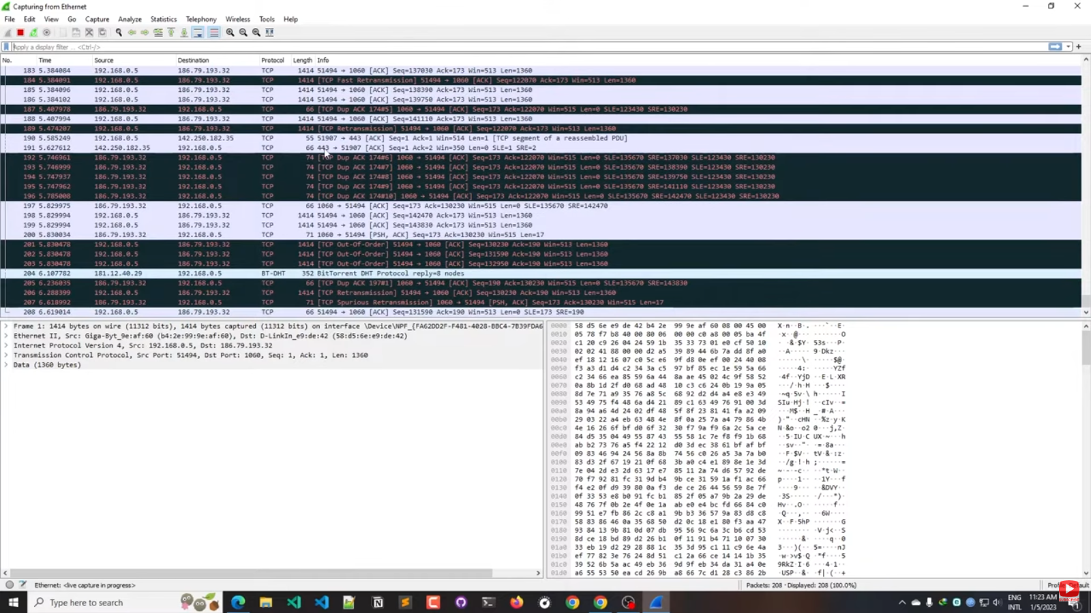

# checking only for TCP protocols

# Enter the tcp in the above search box

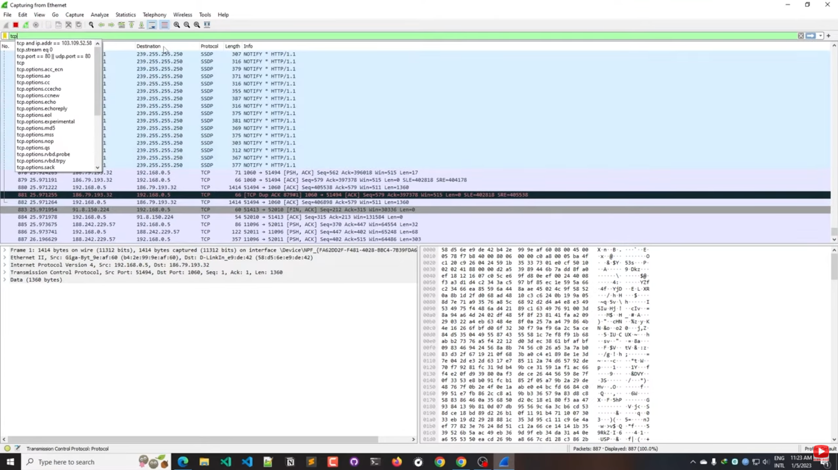

#then all tcp protocols will appear

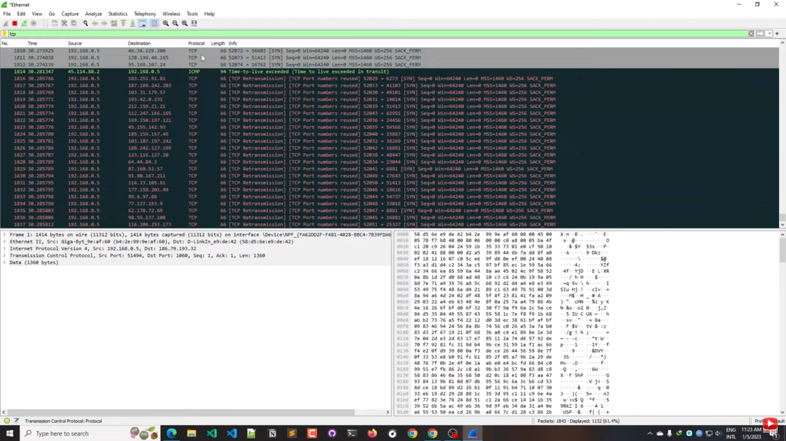

#Like TCP , check for UDP protocols   
# Enter UDP .

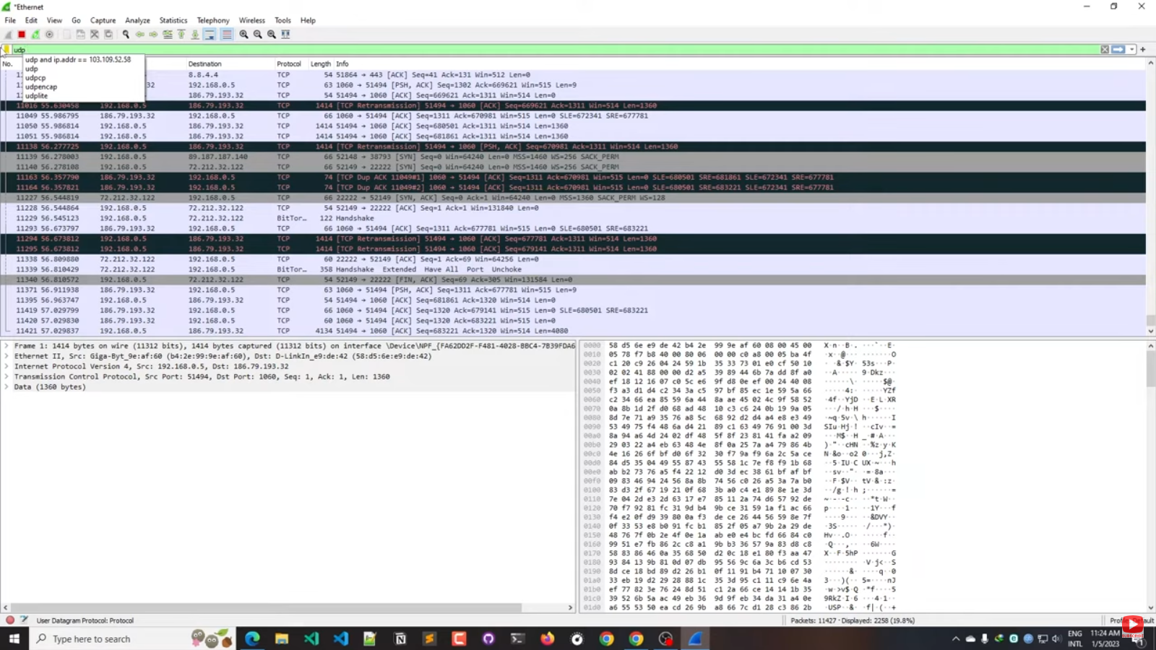

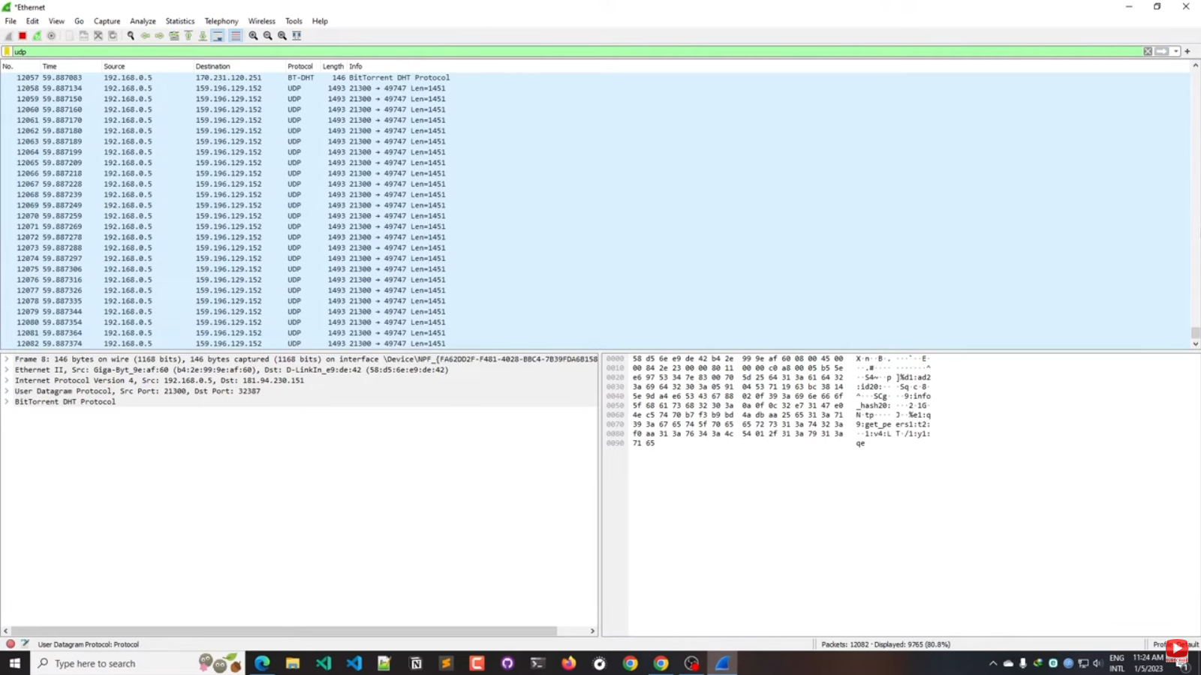

Steps for capture specific website data packets:

* Open the website and get the ip address
* Then open the wireshark and select search box
* Enter the IP address of the site by “ip addr == (ip address)”.
* Then enter, that site data packets will be captures.